# Major Task Marking Criteria

|  |  |  |  |  |  |  |  |  |  |  |  |  |  |  |  |  |  |  |  |  |  |  |  |  |  |  |  |
| --- | --- | --- | --- | --- | --- | --- | --- | --- | --- | --- | --- | --- | --- | --- | --- | --- | --- | --- | --- | --- | --- | --- | --- | --- | --- | --- | --- |
| **Course Code:** | | | **MCT313** | | | | **Course Name:** | | | | **Automation** | | | | | | Major Task | | | | **Date:** | | |  | | | |
| **Student Name:** | | | **Ahmed hisham fathy hassabou** | | | | | | | | | | | | | | | **Student ID:** | | | | **19P4007** | | | | | |
| **Mastery ≥90%** | | | | | | Accomplished ≥75 & <90% | | | | | | | Adequate ≥60 & <75% | | | | | | | Inadequate <60% | | | | | | | |
| **100** | 96 | 93 | | | 90 | 89 | | 84 | 79 | 75 | | | 74 | | 69 | 64 | | | 60 | 59 | | | 40 | | 20 | | 0 |
| * Understand the theoretical background of the automation task * Design and build the actual plant/production line * Design and implement a complete program to achieve the required process control * Design and build an HMI interface to indicate the state of each station on the production line * Comment on the overall project performance * Issue an excellent professional report indicating all results | | | | | | * Understand the theoretical background of the automation task * Design and build the actual plant/production line * Design and implement a complete program to achieve the required process control * Design and partially build an HMI interface to indicate the state of each station on the production line * Comment on the overall project performance * Issue a good professional report highlighting major results | | | | | | | * Understand the theoretical background of the automation task * Design and build the actual plant/production line * Design and implement most of the program to achieve the required process control * Do not manage to build an HMI interface to indicate the state of each station on the production line * Comment on the overall project performance * Issue a fair professional report highlighting some results | | | | | | | * Understand the theoretical background of the automation task * Design and build the actual plant/production line * Design and partially implement the program to achieve the required process control * Do not manage to build an HMI interface to indicate the state of each station on the production line * Comment on the overall project performance * Issue an incomplete report. | | | | | | | |
|  |  |  | | |  | ✅ | |  |  |  | | |  | |  |  | | |  |  | | |  | |  | |  |
| **1st Marker Total** | | | |  | | | | | 1st Marker Signature | | | | | Dr. Mohamed Omar | | | | | | | **ASU** Agreed Mark | | | | | 90 | |
| **2nd Marker Total** | | | |  | | | | | 2nd Marker Signature | | | | | Eng. Hesham Salah | | | | | | | **UEL** Agreed Mark | | | | | 73 | |
| **General Comments:**  **- Good design and implementation of the automation system.**  **- The submitted report was satisfactory but further detailed illustrations and analysis are required.**  **- Acceptable design and implementation of the HMI and its features.**  **- Good comprehension and major contribution to the performed activities.** | | | | | | | | | | | | |  |  |  |  | | --- | --- | --- | --- | | **UEL Grading System** | **Agreed Mark Range** | **ASU Grading Scale** | | | **% equivalent at UEL** | **% at ASU** | **Grade** | | 95% and higher |  | 97% and higher | A+ | | 82% to less than 95% |  | 93% to less than 97% | A | | 70% to less than 82% | ✅ | 89% to less than 93% | A- | | 66% to less than 70% |  | 84% to less than 89% | B+ | | 63% to less than 66% |  | 80% to less than 84% | B | | 60% to less than 63% |  | 76% to less than 80% | B- | | 56% to less than 60% |  | 73% to less than 76% | C+ | | 53% to less than 56% |  | 70% to less than 73% | C | | 50% to less than 53% |  | 67% to less than 70% | C- | | 45% to less than 50% |  | 64% to less than 67% | D+ | | 40% to less than 45% |  | 60% to less than 64% | D | | Less than 40% |  | Less than 60% | F | | | | | | | | | | | | | | | | |
|  |  |  |  |  |  |  |  |  |  |  |  |  |  |  |  |  |  |  |  |  |  |  |  |  |  |  |  |

**MCT313**

**Automation**

**Major Task Phase 1**

**Supervised by**

|  |
| --- |
| Dr. Mohamed Omar |
| Eng. Hesham Salah |

**Submitted by**

|  |  |
| --- | --- |
| Ahmed Hisham Fathy Hassabou | 19P4007 |
| Mohamed Fathi Abdelhamid Ali | *19P4401* |
| Abdel Rahman Ahmed Habash  Mohamed Maged El-Berry | *19P5553*  *19P2698* |

Table of Contents

Table of Figures 2

ABSTRACT 3

1.0 Introduction 4

2.0 Components 5

2.1 S7-1200 CPU 1211C DC/DC/DC 5

2.2 HMI KTP900 Basic PN 5

2.3 Liquid Level Control System 6

2.4 Fill Valve 6

2.5 Level Meter 7

2.6 Discharge Valve 7

2.7 Flow Meter 8

2.8 Electric Board 8

2.9 Warning Light 9

2.10 Alarm Siren 9

3.0 Control Block 10

4.0 Results 10

4.1 PID Parameters (No Disturbance) 10

4.2 PID Parameters (With Disturbance) 13

4.3 Out of range setpoint setting 15

4.4 Forcing outflow while discharge valve is closed 19

4.5 Forcing errors in Inlet, Discharge valves and level meter sensor 21

5.0 Drive Link 22

6.0 Conclusion 23

# Table of Figures

Figure 1 S7-1200 CPU 1211C DC/DC/DC 5

Figure 2 HMI KTP900 Basic PN 5

Figure 3 Liquid Level Control System 6

Figure 4 Fill Valve 6

Figure 5 Level Meter 7

Figure 6 Discharge Valve 7

Figure 7 Flow Meter 8

Figure 8 Electric Board 8

Figure 9 Warning Light 9

Figure 10 Alarm Siren 9

Figure 11 PID Parameters (No Disturbance) 11

Figure 12 Graph PID Parameters (No Disturbance) 12

Figure 13 PID Parameters (With Disturbance) 13

Figure 14 Graph PID Parameters (With Disturbance) 14

Figure 15: Calculated Parameters 15

Figure 16: Graph for system with PID parameters calculated 16

Figure 17 Out of range setpoint setting 17

Figure 18 Warning Notification for out-of-range setpoint setting 18

Figure 19 Forcing outflow while discharge valve is closed 19

Figure 20 Warning Notification for forcing outflow while discharge valve is closed 20

Figure 21 Forcing errors in Inlet, Discharge valves and level meter sensor 21

# ABSTRACT

In industrial automation, controlling the water level in a tank is a common process requirement. To achieve this, programmable logic controllers (PLCs) are often used along with specialized software such as TIA Portal and Factory IO. TIA Portal is a powerful engineering software used for configuring, programming, and commissioning industrial automation systems, while Factory IO is a virtual factory simulation software that enables the testing and visualization of automation projects.

PID control is a widely used control technique for regulating process variables such as temperature, pressure, and flow rate. In this project, TIA Portal is used to implement a PID control algorithm to regulate the water level in a tank in Factory IO. The system is modeled in Factory IO, and the level of water in the tank is sensed by a simulated level sensor. The PID controller is designed to adjust the flow rate of water into the tank to maintain the desired water level.

The performance of the control system is evaluated by measuring the rise time, settling time, and overshoot of the water level response. The simulation results demonstrate that the PID controller is capable of regulating the water level in the tank accurately and efficiently.

In conclusion, this project highlights the effectiveness of TIA Portal and Factory IO in implementing a PID control algorithm to regulate the water level in a tank. This approach can be used in real-world applications to control the water level in industrial processes, such as in chemical plants, water treatment plants, and food processing plants.

# 1.0 Introduction

Controlling liquid levels in tanks is important in several industrial applications, and it is often achieved through PLCs and specialized software. TIA Portal is a widely-used engineering software that enables automation system configuration, programming, and commissioning in various industries. This project aims to demonstrate the implementation of a water level control system using TIA Portal, where the control of a water level tank simulated in Factory IO is regulated. The project involves modeling the tank in Factory IO, designing a ladder diagram-based control logic in TIA Portal, and programming the PLC to control the tank's water level. The performance of the control system will be evaluated using metrics such as rise time, settling time, and overshoot. The project showcases the effectiveness of combining TIA Portal and Factory IO to develop a dependable and robust water level control system.

# 2.0 Components

## 2.1 S7-1200 CPU 1211C DC/DC/DC

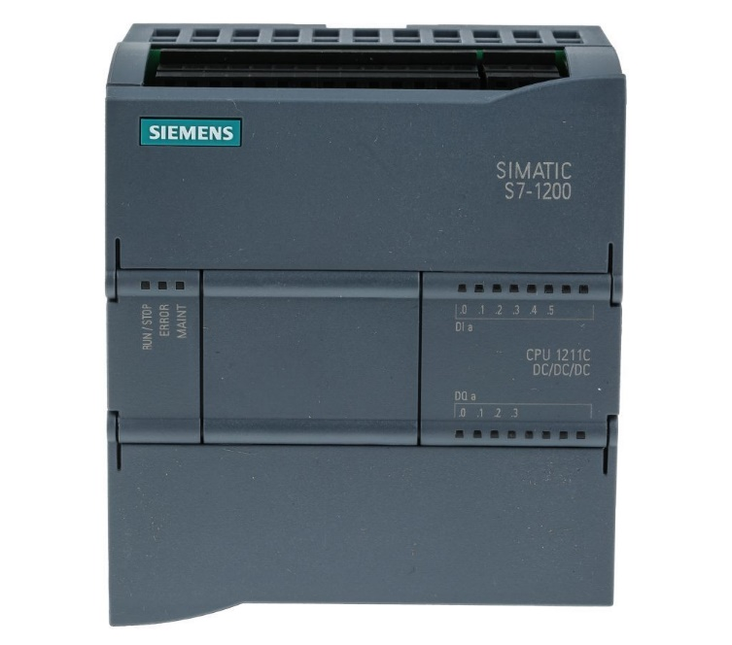

Figure S7-1200 CPU 1211C DC/DC/DC

## 2.2 HMI KTP900 Basic PN

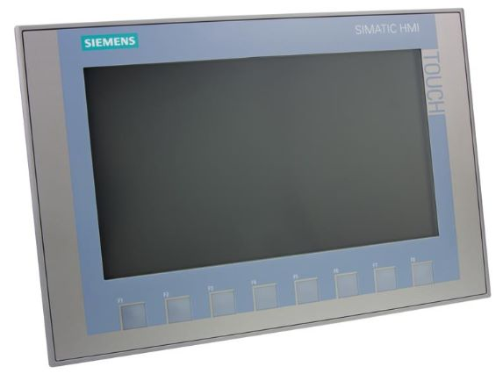

Figure HMI KTP900 Basic PN

## 2.3 Liquid Level Control System

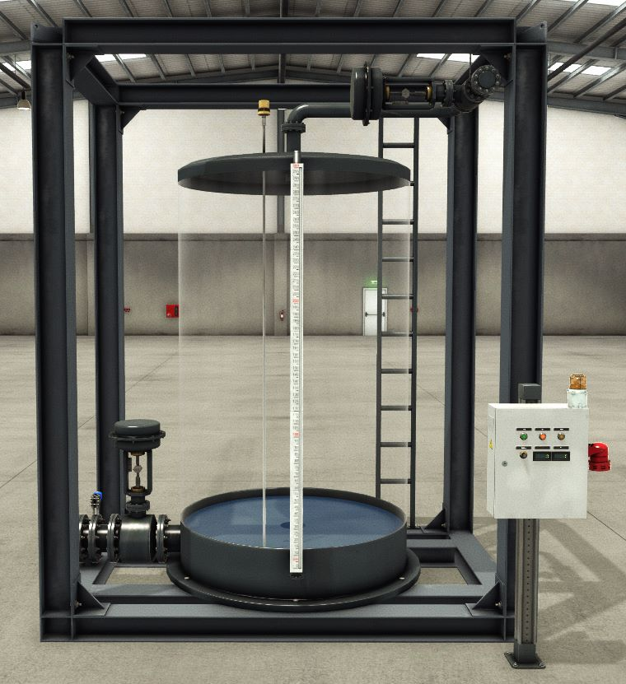

Figure Liquid Level Control System

## 2.4 Fill Valve

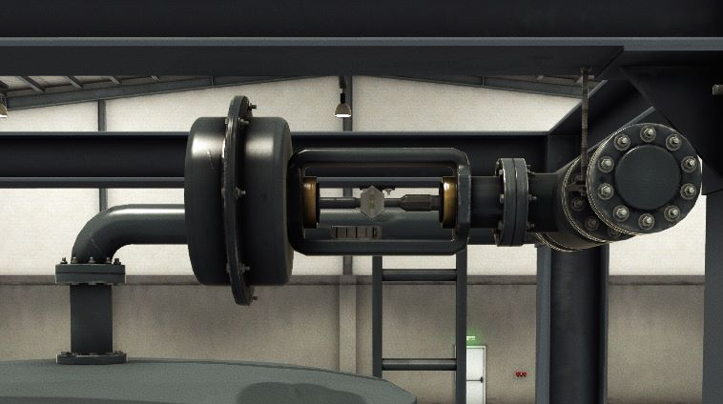

Figure Fill Valve

## 2.5 Level Meter

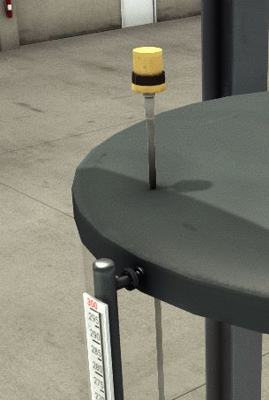

Figure Level Meter

## 2.6 Discharge Valve

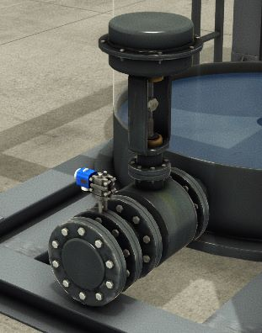

Figure Discharge Valve

## 2.7 Flow Meter

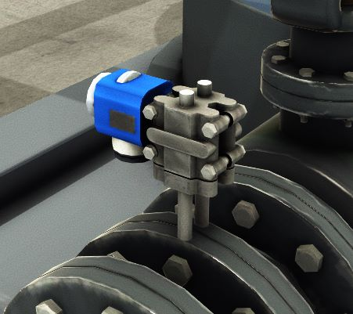

Figure Flow Meter

## 2.8 Electric Board

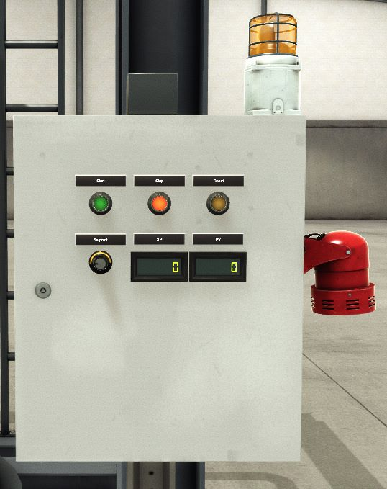

Figure Electric Board

## 2.9 Warning Light

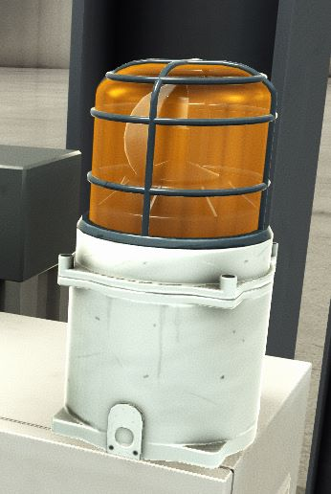

Figure Warning Light

## 2.10 Alarm Siren

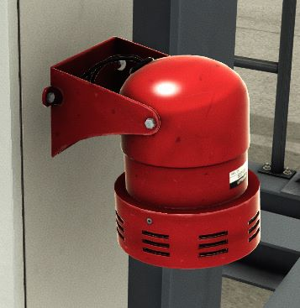

Figure Alarm Siren

# 3.0 Block Diagrams

## 3.1 System Block

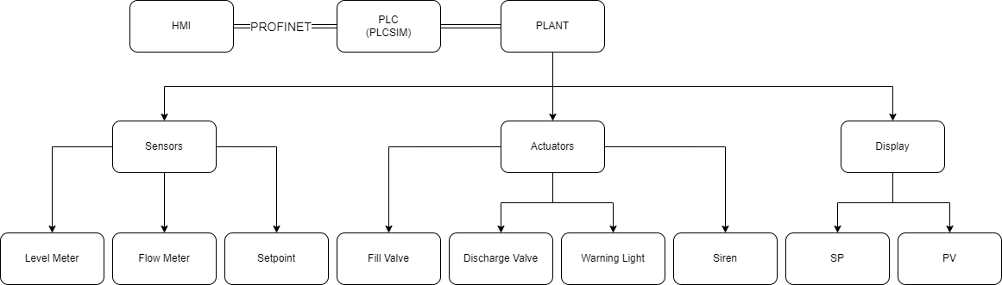

## 3.2 Controller Block

# 4.0 Results

## 4.1 PID Parameters (No Disturbance, Trial & Error)

These Parameters are used when there’s no disturbance in the system meaning that the discharge valve is not opened at all

PID Parameters:

* Kp = 2.5
* Ti = 0.0
* Td = 0.0

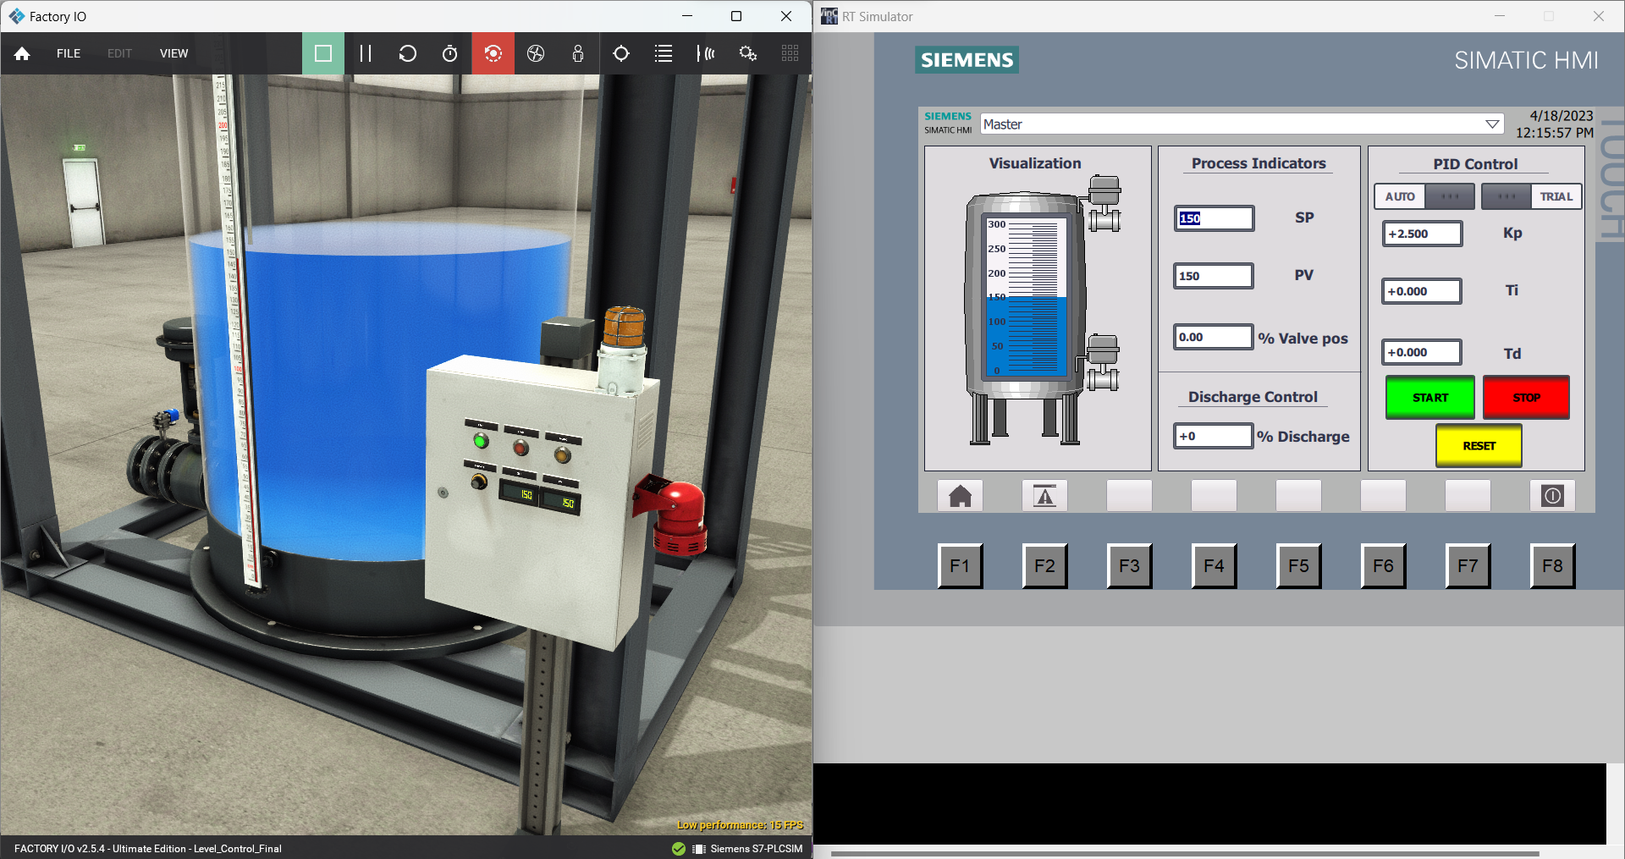

Figure PID Parameters (No Disturbance)

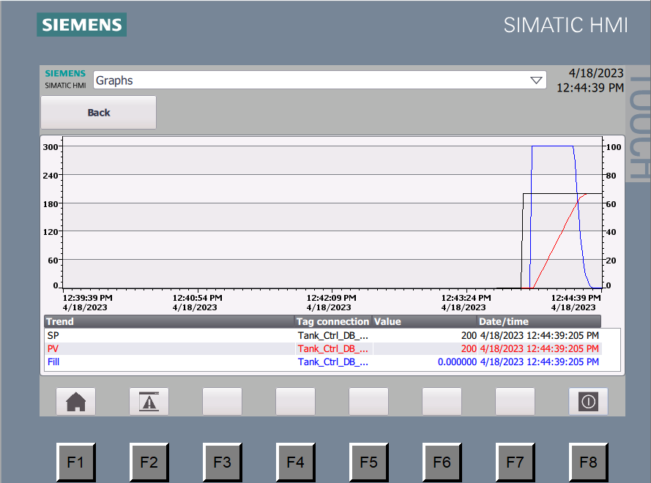

Figure Graph PID Parameters (No Disturbance)

## 4.2 PID Parameters (With Disturbance, Trial & Error)

These Parameters are used when there’s disturbance in the system meaning that the discharge valve is opened

PID Parameters:

* Kp = 2.5
* Ti = 10.0
* Td = 0.0

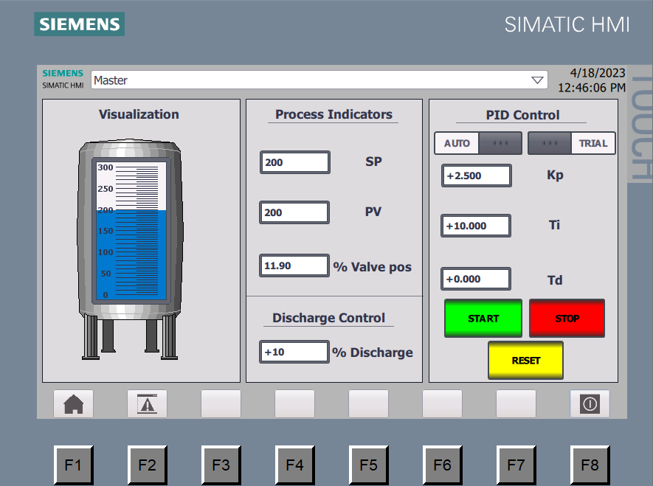

Figure PID Parameters (With Disturbance)

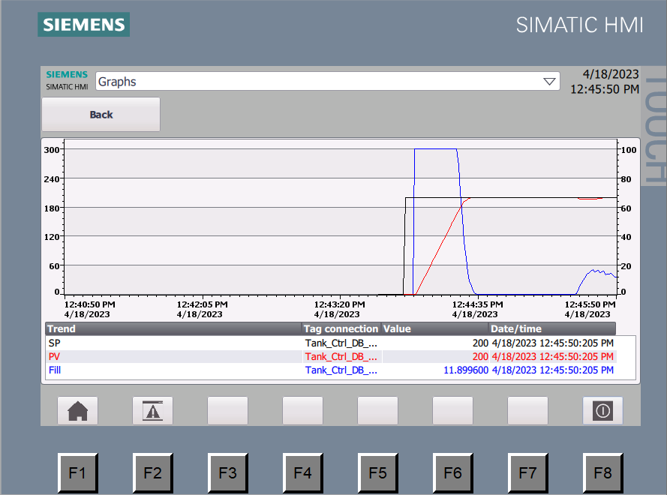

Figure Graph PID Parameters (With Disturbance)

## 4.3 PID Parameters (With Disturbance, Calculated)

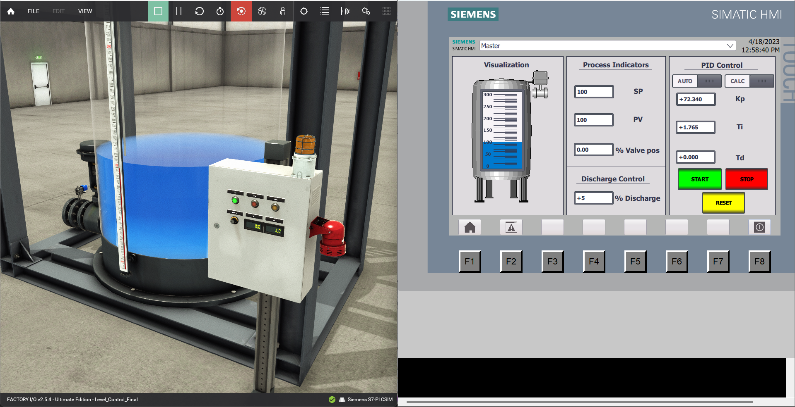

Figure : Calculated Parameters

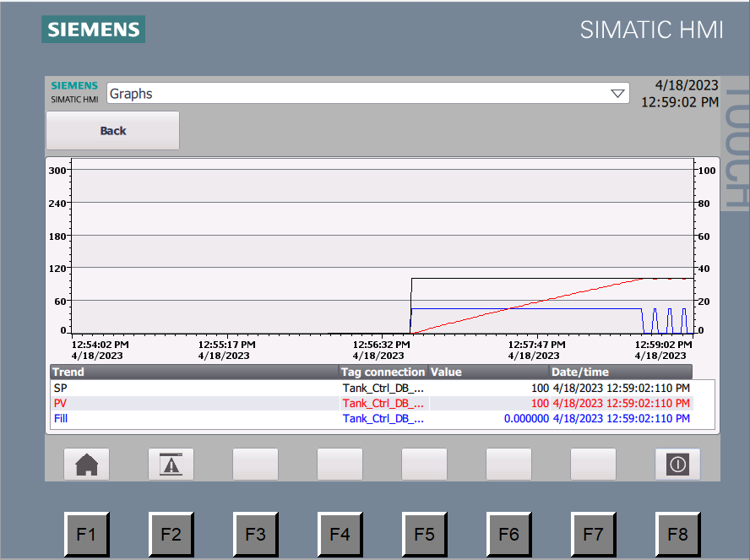

Figure : Graph for system with PID parameters calculated

## 4.4 Out of Range Setpoint Setting

If the Setpoint is out of range the following events occur

* System Stops
* Warning Light lights
* Warning appears inside alarm HMI

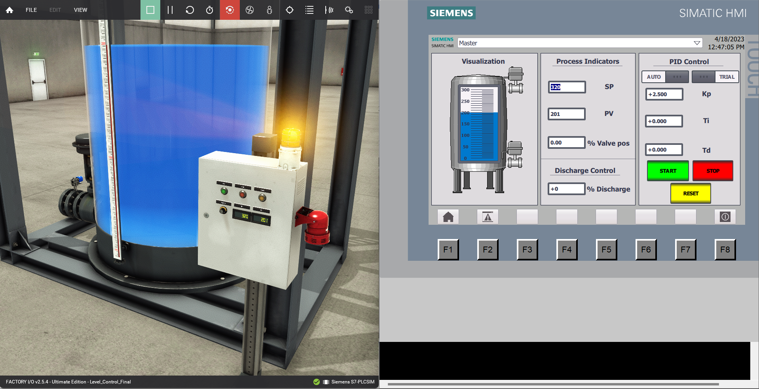

Figure Out of range setpoint setting

The Alarm HMI is where all Error and Warning messages appear.

In Figure 16, a warning message appears when the setpoint was declared out of range

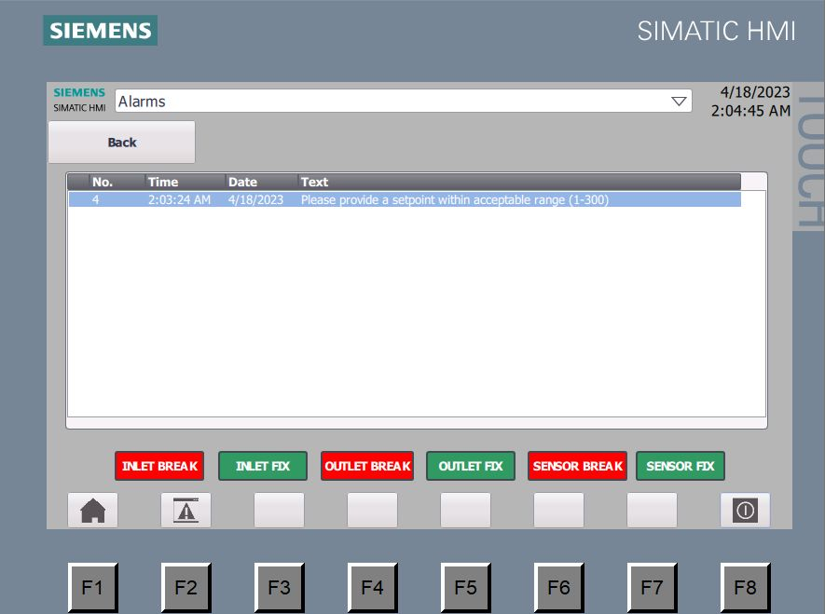

Figure Warning Notification for out-of-range setpoint setting

## 4.5 Forcing outflow while discharge valve is closed

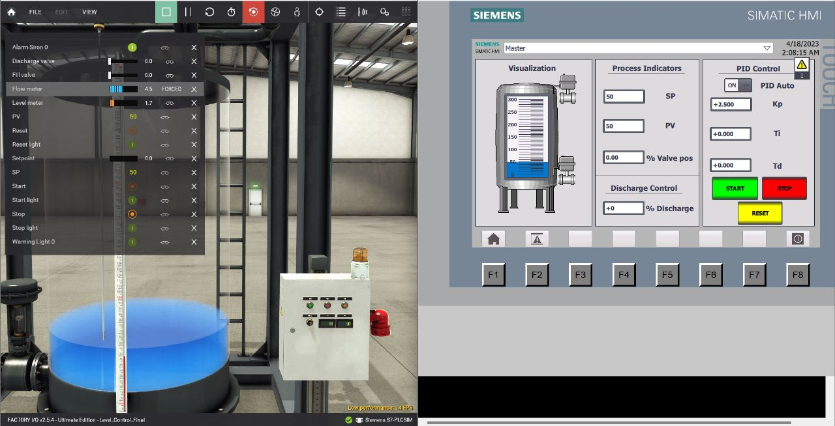

Figure Forcing outflow while discharge valve is closed

In Figure 18, a warning message appears when valve is not operating properly as flow meter is reading while valve is closed

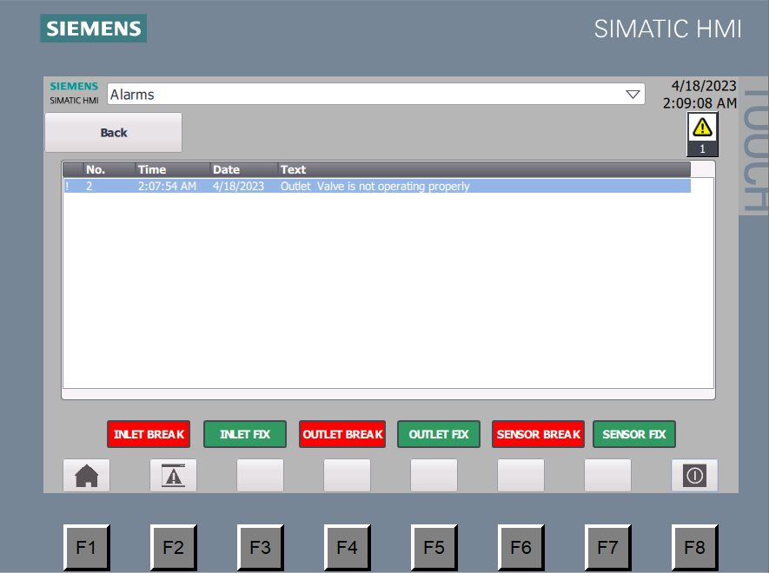

Figure Warning Notification for forcing outflow while discharge valve is closed

## 4.6 Forcing errors in Inlet, Discharge valves and level meter sensor

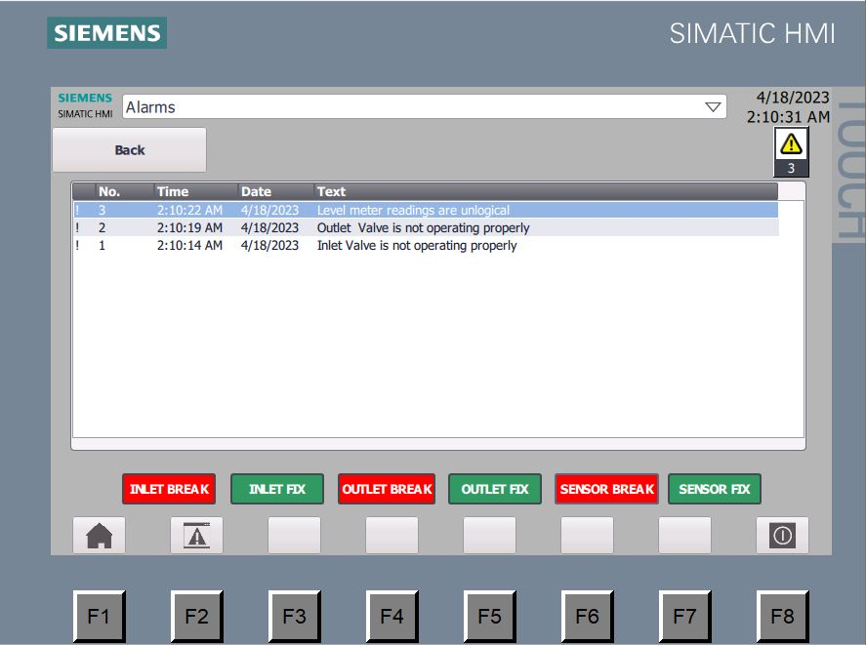

Figure Forcing errors in Inlet, Discharge valves and level meter sensor

# 5.0 Drive Link

Link: <https://drive.google.com/file/d/1G1T_TvJkfsN_ua211MG8a_QHr-3YHPZ6/view?usp=share_link>

# 6.0 Conclusion

In conclusion, using TIA Portal to control a water level tank on Factory IO using a PID controller is a highly effective method for regulating fluid levels in industrial processes. The PID controller algorithm continuously monitors and adjusts the control parameters to maintain a desired level of fluid in the tank, ensuring accuracy and stability in the system. Additionally, TIA Portal offers a user-friendly interface and a wide range of tools and functions for programming and monitoring the system, making it a popular choice for industrial automation applications. Overall, the combination of TIA Portal and PID control provides an efficient and reliable solution for managing water levels in industrial processes.